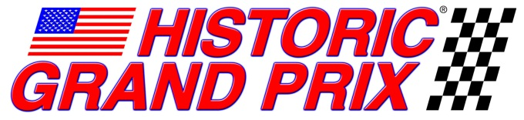
For immediate release
February 2, 2012
North Salem, NY: Historic Grand Prix, America’s spectacular vintage Formula One Racing group, announced today it will be featured at the SVRA Fall event at Watkins Glen International Raceway, September 7-9, 2012. The HGP drivers will be racing for the coveted “Governors Cup Trophy”, an award that goes back to the earliest events at the Glen. Watkins Glen International Raceway is the original home of Formula One racing in the United States, making this year’s event all the more nostalgic for participants and fans alike.
Historic Grand Prix will bring back to the Glen many of the actual F1 cars driven there in the 1970’s by Niki Lauda, James Hunt, Mario Andretti, Ronnie Petersen, Alan Jones, Gilles Villeneuve, Jody Scheckter and many others. The promise of hearing the barking of Cosworth DFV’s and howling of Ferrari 12 cylinder engines working their way around the historic 3.4 mile circuit should awaken memories of the many great GP’s at the Glen
SVRA’s U.S. Vintage Grand Prix has long been a popular fixture on the historic racing calendar and is one of the largest events in the USA. The weekend includes the full array of vintage racing cars from the big engined Can-Am cars to iconic European Grand Touring and Prototype sports cars. A highlight of the 3-day event will be a re-enactment of the original 1950’s road race through the village of Watkins Glen for selected groups of cars.
"To be able to drive the Lotus 79 at the Glen is a serious honor.” says Duncan Dayton, one of HGP’s earliest members and long-time owner of the Lotus 79 originally driven by Mario Andretti. “I was standing on the grid next to the car in 1978 as Mario was strapping in to start the USGP. I thought I had a better chance of being an astronaut, than one day owning and driving that car. The circuit is very challenging and a real drivers track... challenging, technical and fast. There is a natural rhythm to the course that is very appealing. I can't wait to go back and once again hear the roar of DFVs on full song reverberating through the beautiful Finger Lakes Region!"
To learn more about this event, please visit both SVRA and the Watkins Glen International Raceway websites: www.svra.com or www.theglen.com
Historic Grand Prix is a vintage racing organization which showcases the 3-litre era of Formula One, the cars from 1966 through 1983. It was a unique time when the rules stayed constant and the tough and powerful Cosworth DFV engine was available to everyone and thoroughly competitive. This situation produced a wide variety of cars and stellar competition. Since 2000, Historic Grand Prix has staged races for these cars throughout North America, including support races at the Canadian and United States Grands Prix, as well as IRL, CART and the premier historic race meetings in the U.S. For more information on Historic Grand Prix, please visit our Website at www.historicgrandprix.com.
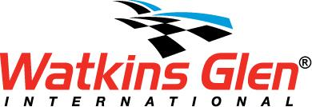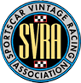

Duncan Dayton leading the pack in his 1978 Lotus 79
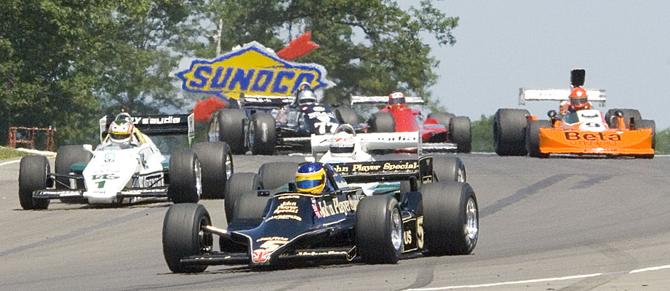

Chris Locke in his 1976 Lotus 77 and Chris MacAllister in his 1976 Ferrari 312T2
