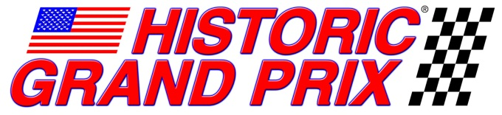

For immediate release
February 2, 2012
North Salem, NY: Historic Grand Prix, America’s spectacular vintage Formula One racing group announced today it will be featured at the Lime Rock Park Fall Festival, Aug. 31 through Sept. 3, 2012. The popular Labor Day event will honor Sir Stirling Moss, one of the greatest Grand Prix drivers of all time, giving the HGP drivers special incentive to put on their best show.
Lime Rock’s Fall Festival celebrates its 30th anniversary this year giving added significance to HGP’s first appearance at the event. The sights and sounds of powerful F1 cars at the historic facility promises to be exciting viewing and when coupled with HGP’s very spectator friendly paddock display, allows fans an experience not possible in contemporary racing.
“While the track is a bit short in length, it makes up for it in fun!” said Bud Moeller, a stalwart HGP owner/driver. “Zipping around Lime Rock in an F1 car is like being at a go-kart track on steroids” added the driver of an ex-Gilles Villeneuve 1979 Ferrari 312 T5.
More information and tickets are available at www.limerock.com
Historic Grand Prix is a vintage racing organization which showcases the 3-litre era of formula one, the cars from 1966 through 1983. It was a unique time when the rules stayed constant and the tough and powerful Cosworth DFV engine was available to everyone and thoroughly competitive. This situation produced a wide variety of cars and stellar competition. Since 2000 HGP have staged races for these cars throughout North America, including support races at the Canadian and United States Grands Prix, as well as IRL, CART and the premier historic race meetings in the US. For more information on HGP visit www.historicgrandprix.com.

